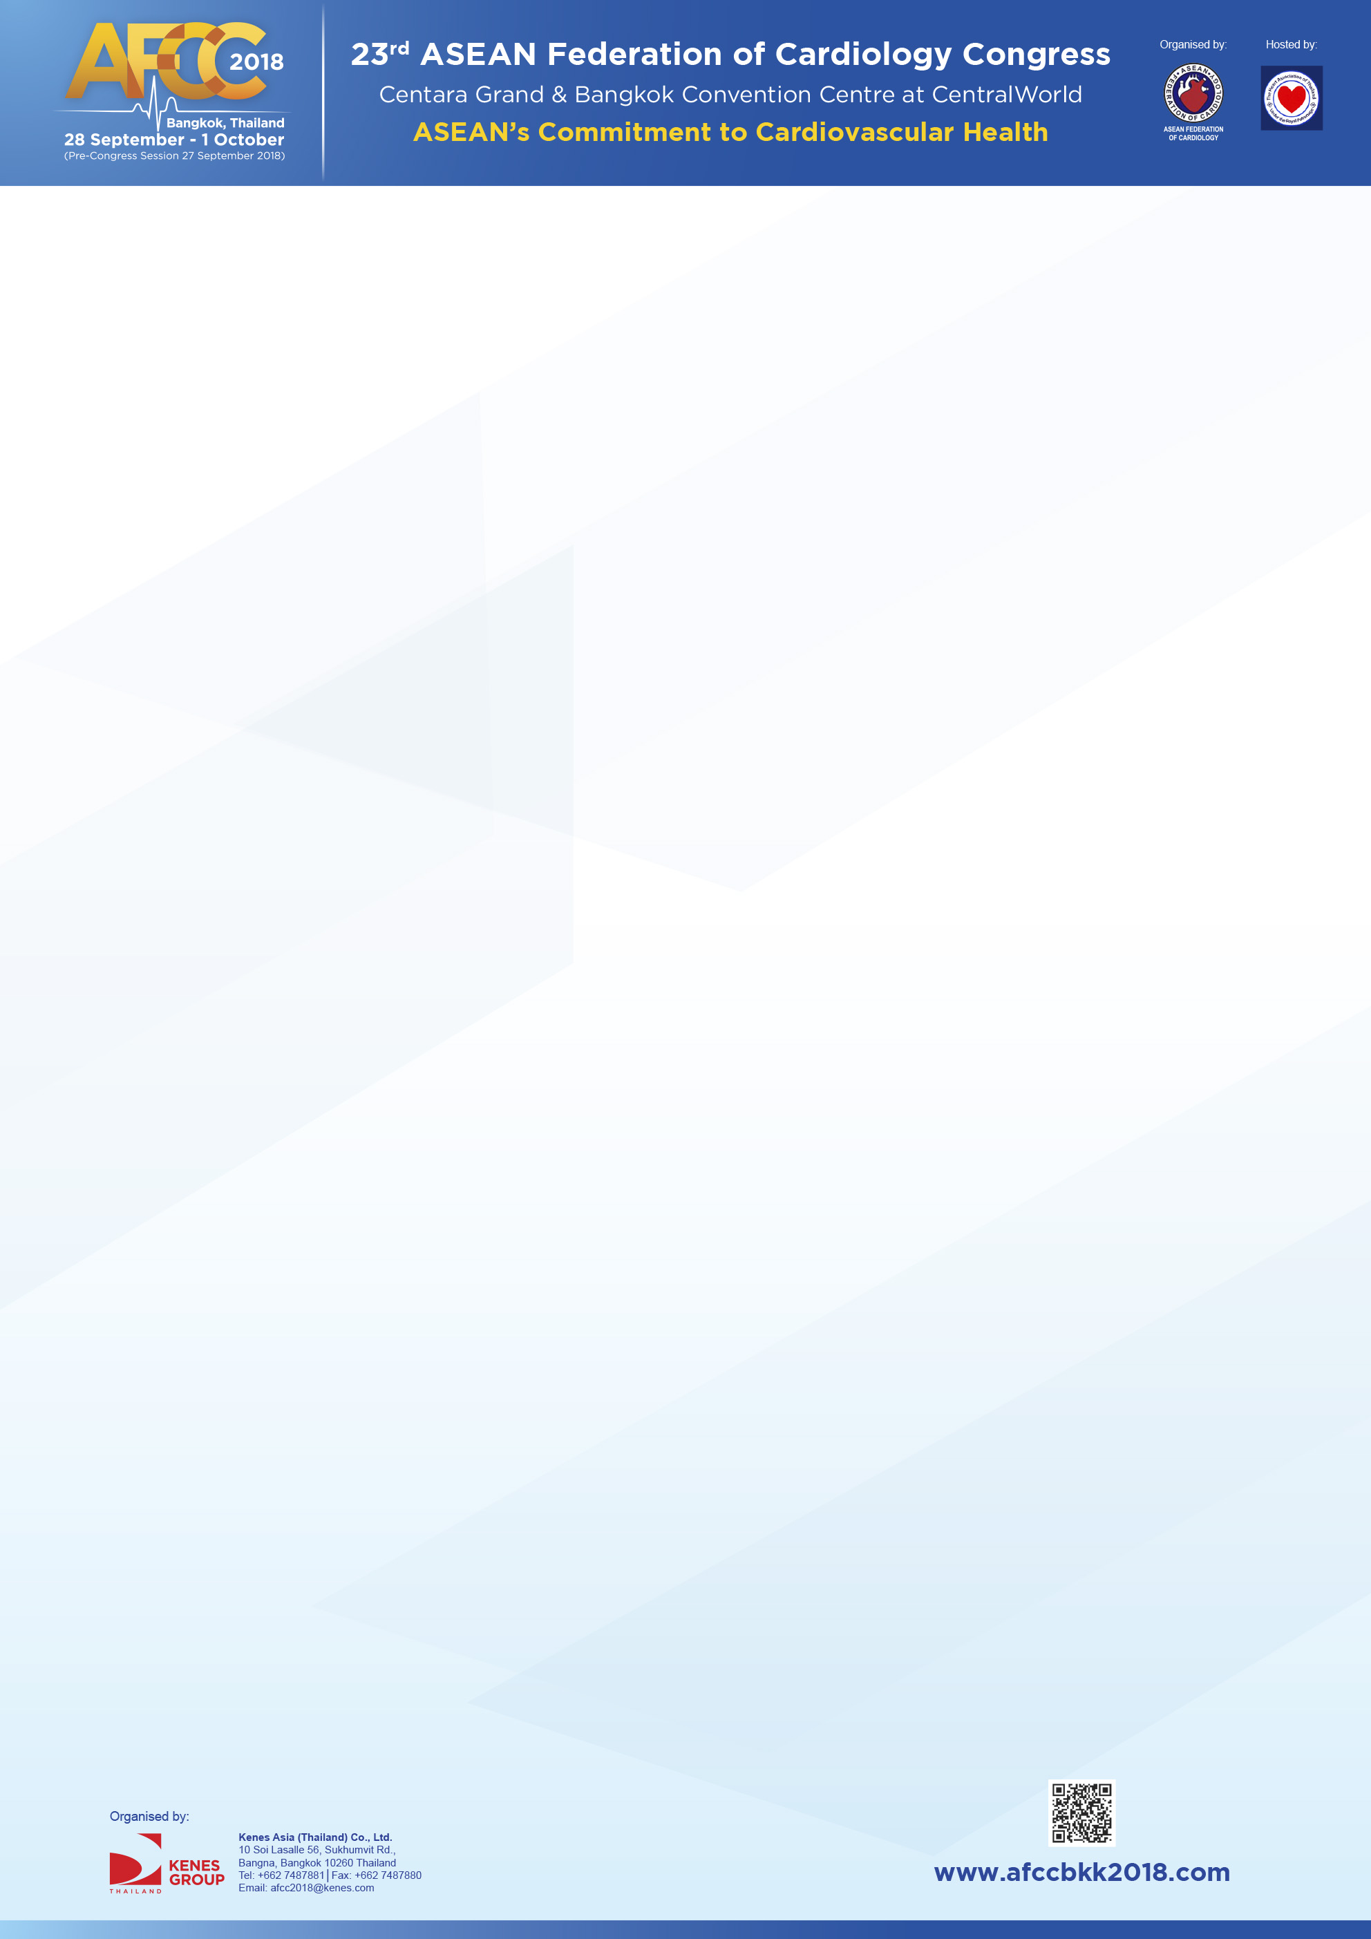

**Symposium Session**

|  |  |
| --- | --- |
| **Company** | Bayer Thai Company Limited |
| **Symposium Date** | 29 Sep 18 |
| **Symposium Time** | 12.30-14.00 |
| **Symposium Room** | Lotus 3-4 |
| **Contact Person** | Kesuma Sinthusarn |
| **Contact Number** | 089-7861196 |
| **Symposium/Session Title** | State of the Art in Managing Multi-Morbid AF Patients with NOAC |
| **Chairs (with countries)** | Dr. Thoranis Chantrarat, Thailand  Prof. Jafna Layth Cox, Canada |
| **Proposed Agenda** | Include presentation titles, speakers’ full name and country, as well as schedule of the session from introduction to Q&A (if any).  12.30-12.35 : Welcome and Opening (5 mis)  Dr. Thoranis Chantrarat, Thailand  12.35-13.25 : Untangling the evidence: Which Data are Relevant to Multi-Morbid AF Patients (40 mins)  Dr. Thoranis Chantrarat, Thailand  13.25-13.55 : How Can We Apply NOAC in Real World Practice (40 mins)  Prof. Jafna Layth Cox, Canada  13.55-14.00 : Q & A  Dr. Thoranis Chantrarat, Thailand/ Prof. Jafna Layth Cox, Canada |