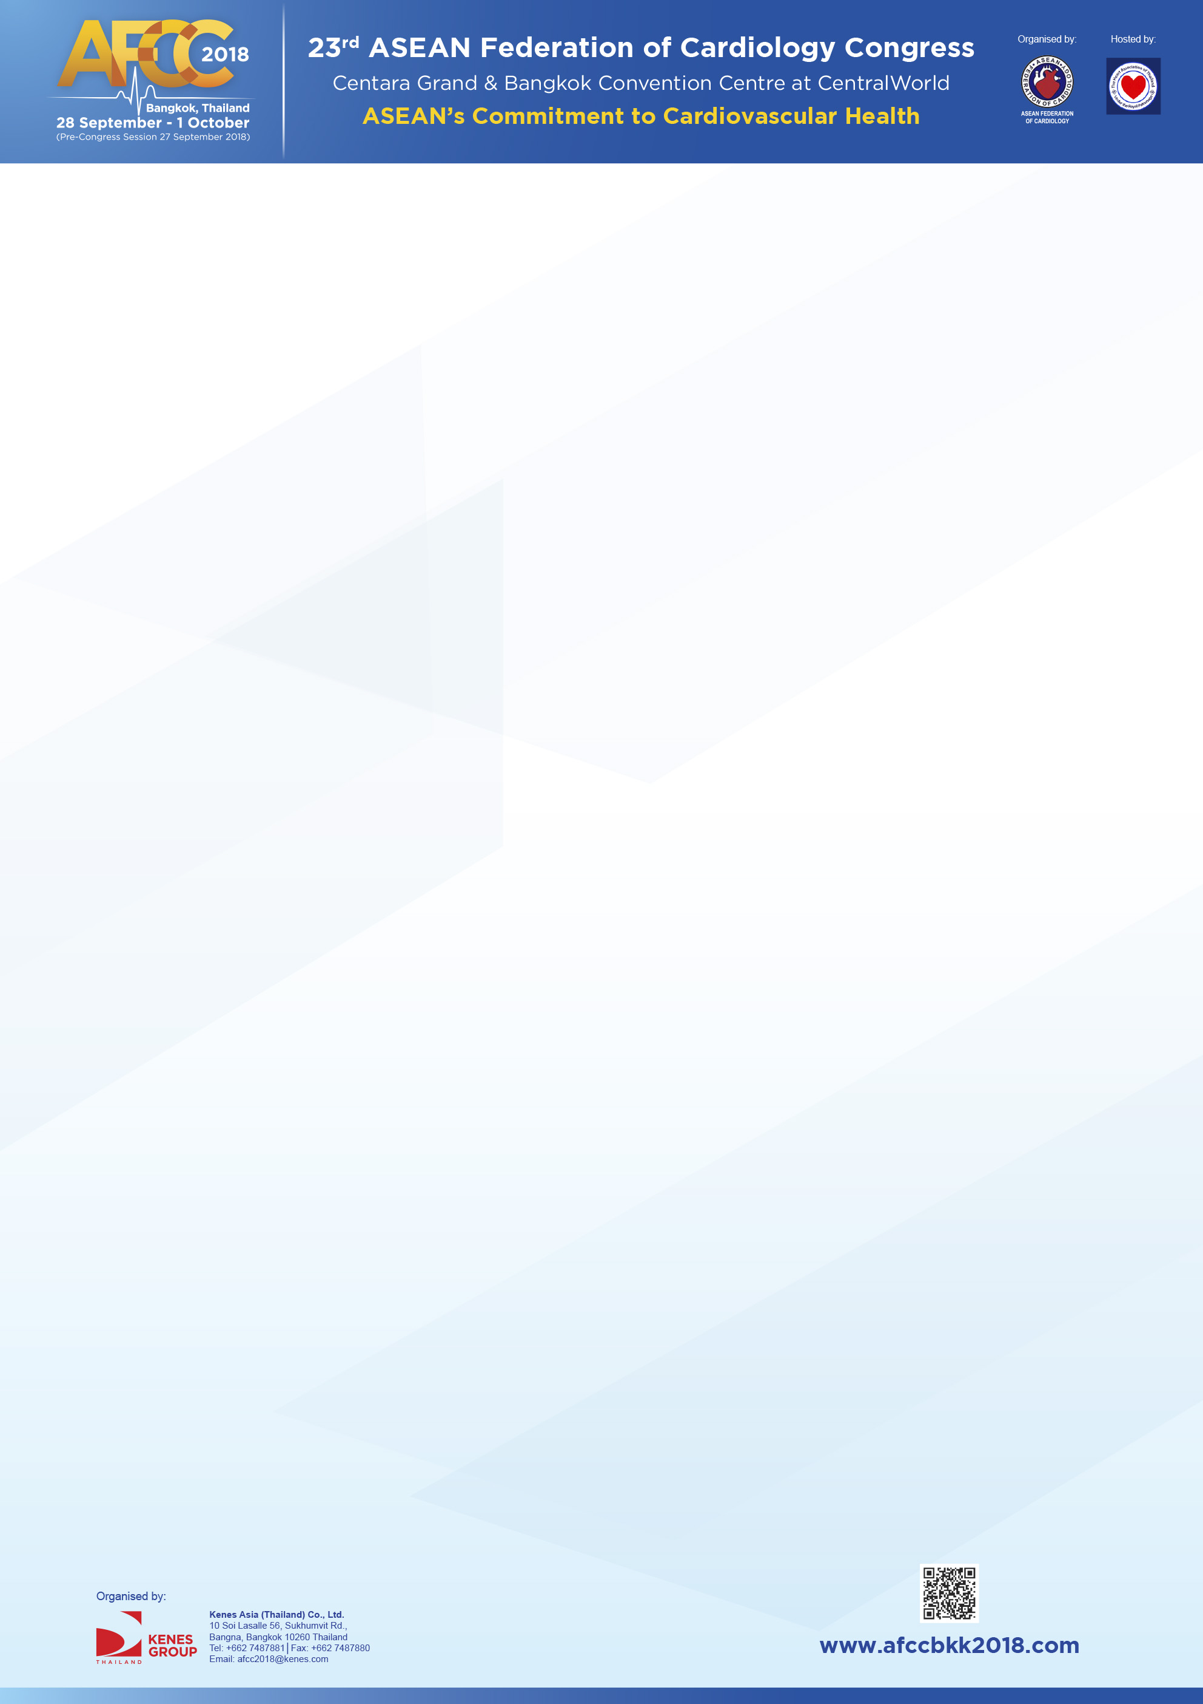

**Educational Symposium Session**

|  |  |
| --- | --- |
| **Company** | Boehringer Ingelheim (Thailand) Ltd. |
| **Symposium Date** | 29 Sep 2018 |
| **Symposium Time** | 11.00-12.30 |
| **Symposium Room** | Ballroom C |
| **Contact Person** | Anongporn Nilanont |
| **Contact Number** | 086-8906030 |
| **Symposium/Session Title** | Efficacy, Safety and Control : The New Standard in Anticoagulation Care |
| **Chairs (with countries)** | Thoranis Chantrarat, M.D., Phramongkutklao Hospital, Thailand |
| **Proposed Agenda** | |  |  |  | | --- | --- | --- | | Time | Program | Presented by | | 11:00 | Opening Remarks | Chairman | | 11.00– 11.40  (40 minutes) | Full Coverage Spectrum of NOACs | Thoranis Chantrarat, M.D.,  Thailand | | 11:40– 12.20  (40 minutes) | Case Based Approach in Emergency Management and Real World Evidence | Asst. Prof. Pattarapong Makarawate, M.D.  Thailand | | 12.20-12.30  (10 minutes) | Q&A and Closing Remarks | Chairman | |